TEST CASE 6 POI REPORT

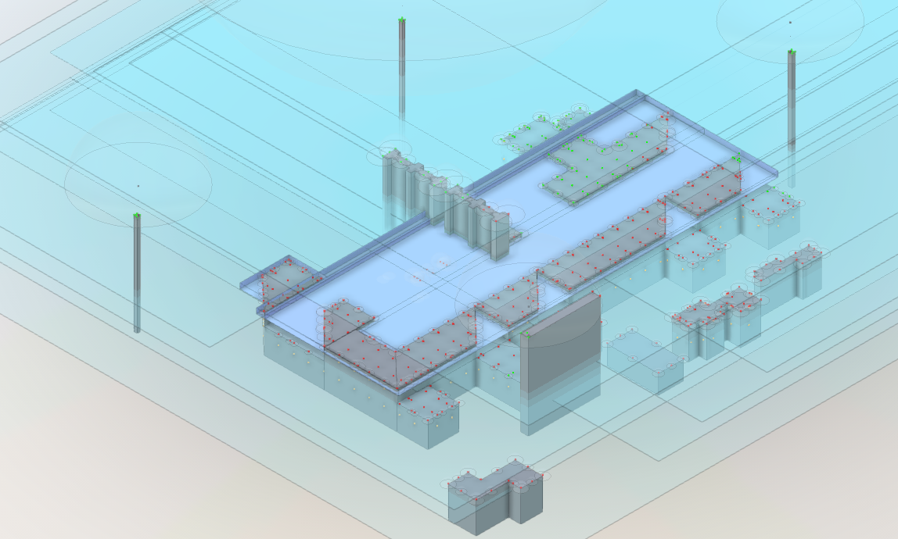

Table of Contents

Equations for Multi-building Reductive 2

POI7, POI8 3

POI 15 4

POI 17 5

POI 26, POI 27 6

POI 31, POI 32, POI 33, POI 34 7

POI 93, 94, 95, 96 8

## Equations for Multi-building Reductive

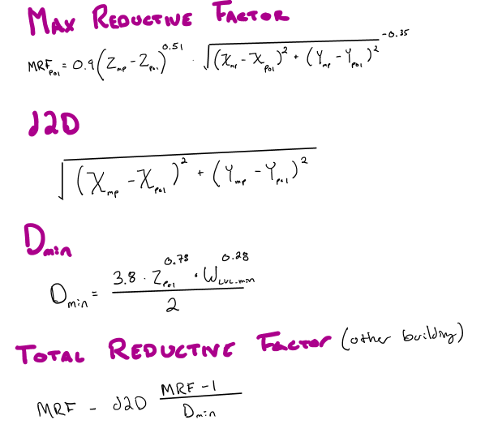

## POI7, POI8

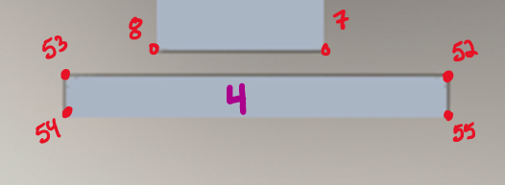

Both of these pulled a point from edge that was manually placed between 52 and 53. This makes more sense than 52 or 53. Removing the point between 53 and 52 does allow for point 8 to pull point 53 as the magic point and point 7 to pull point 52 as the magic point.



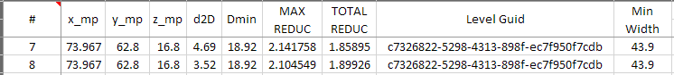

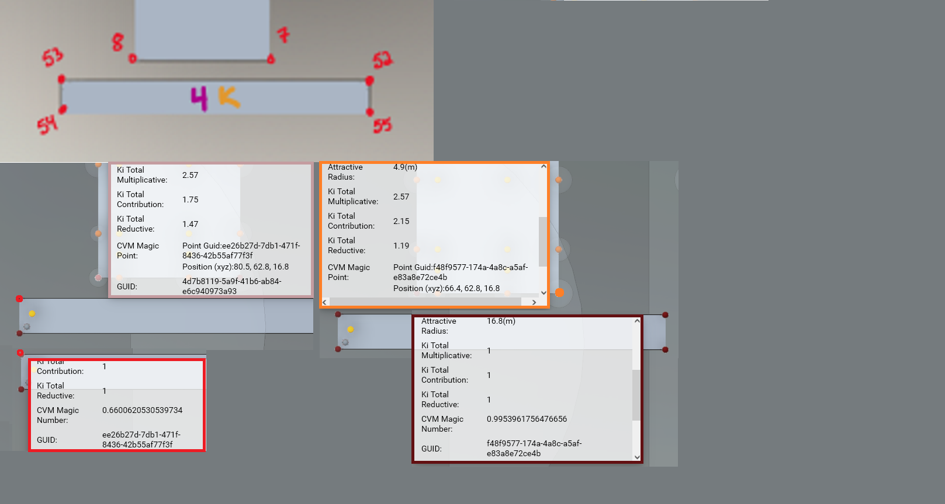

## POI 15

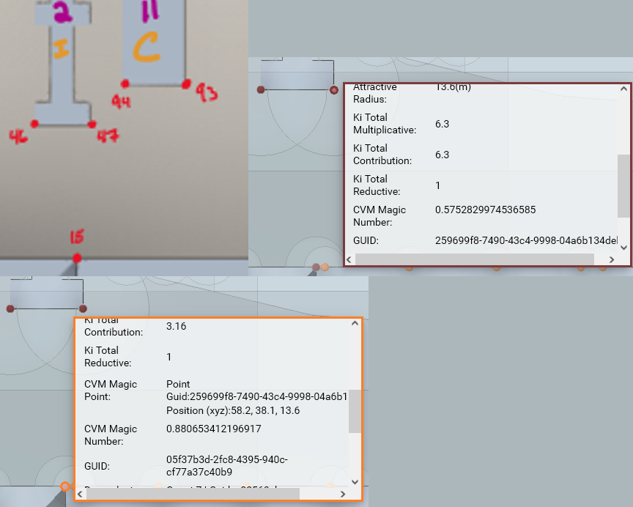

POI15 pulls in the proper magic point but does not obtain the final value that it was supposed to.





## POI 17

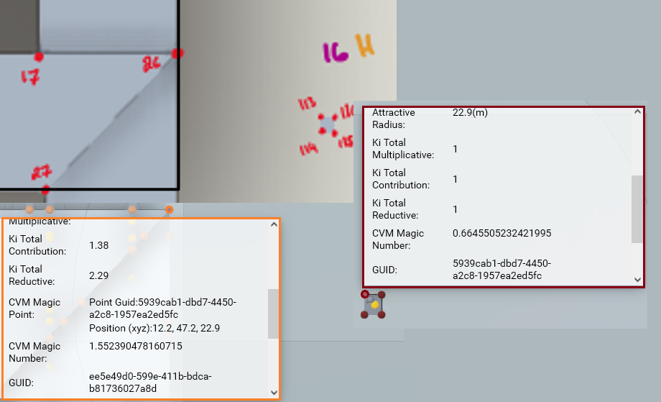

POI17 pulls in the proper magic point but does not obtain the final value that it was supposed to.





## POI 26, POI 27

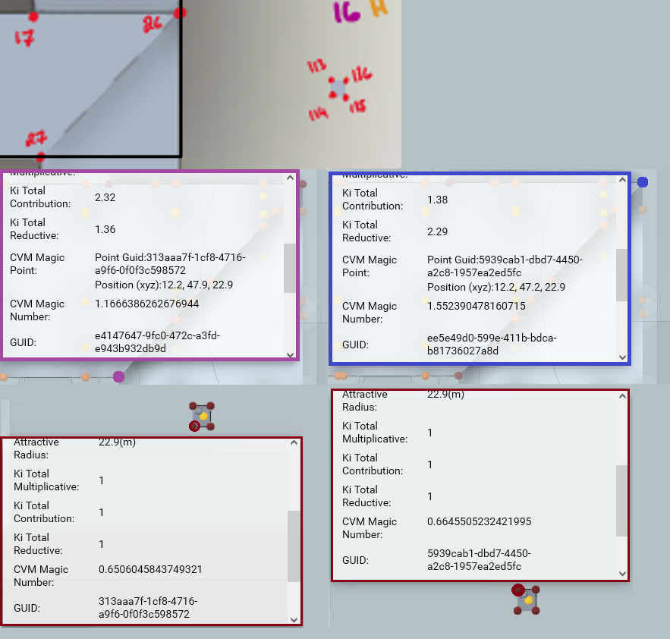

POIs 26, 27 pulls in the proper magic point but does not obtain the final value that it was supposed to.



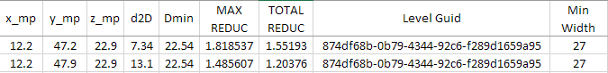

## POI 31, POI 32, POI 33, POI 34

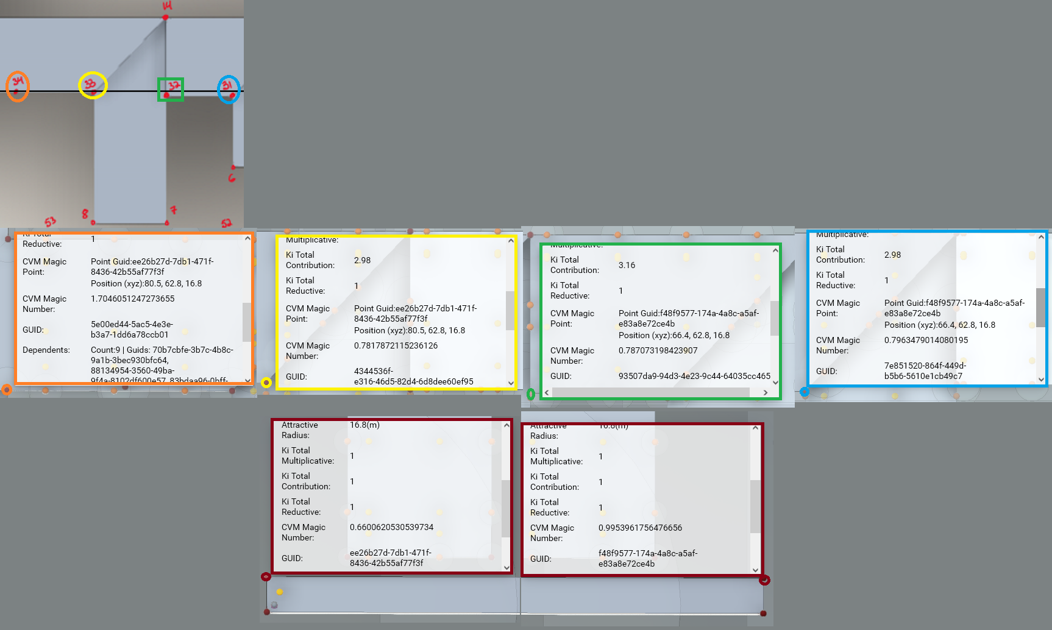

POIs 31, 32, 33, 34 pulls in the proper magic point but does not obtain the final value that it was supposed to.

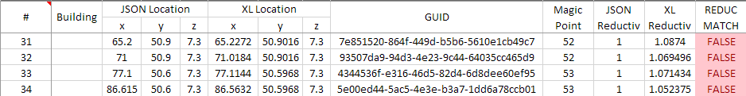

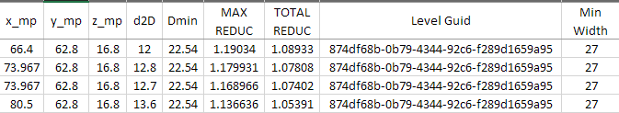

## POI 93, 94, 95, 96

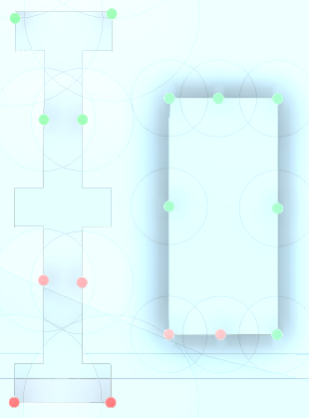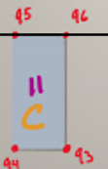

POIs 93, 94, 95, 96 do not pull any magic number nor do they generate any reductive values